CANDIDATE NAME ____________________________ CG________
 | DUNMAN HIGH SCHOOL (SENIOR HIGH)  YEAR 6 PRELIMINARY EXAMINATION 2010
 | H1 CHEMISTRY  Paper 2 | 8872/02  20 September 2010  2 hours
Additional materials:
Answer Paper
Data Booklet

INSTRUCTIONS TO CANDIDATES
- Write your name and class on all the work you hand in.
- Write in dark blue or black pen on both sides of the paper.
- You may use a soft pencil for any diagrams, graph or rough working.
- The number of marks is given in brackets [ ] at the end of each question or part question.
- You may use a calculator.
- At the end of the examination, fasten all your work securely together.

Section A

FOR EXAMINER’S USE
Question | Marks
1 | /10
2 | /10
3 | /10
4 | /10
Paper 2 Section A | /40
5 | /20
6 | /20
7 | /20
Paper 2 Section B | /40
Paper 1 | /40
Total | /110
Grade
Answer all questions.
Section B
Answer two questions on separate answer paper.

1(a) It has always been stated that the elements of the Periodic Table show general trend from metallic to non–metallic behavior, coupled with an increase of oxidation state of their compounds.
Oxidation State

+8
+7
+6
+5
+4
+3
+2
+1

Na Mg Al Si P S Cl
= oxidation state of oxides of Period 3 elements

(i) Mark with a cross (X) on the diagram the highest oxidation state of the oxide of chlorine.

(ii) Magnesium and aluminium are both metals. Explain, with the aid of appropriate equations, why magnesium oxide reacts with only acids but aluminium oxide reacts with both acids and bases.
..
[[
[4]

1(b) Magnesium oxide, phosphorus pentoxide and phosphorus pentachloride all exist as white solids. Suggest reactions you could carry out to distinguish between the three compounds, writing equations where appropriate.
..
[[
[3]

(c) Phosphorus pentachloride can undergo decomposition at high temperature to form phosphorus trichloride and chlorine. This reaction is known to be a first–order reaction.
PCl₅(g) PCl₃(g) + Cl₂(g)

(i) Explain what is meant by first–order reaction.
..

(ii) Given that the rate constant for the reaction is 1.55 x 10^{–3} s^{–1}, calculate the time taken for the concentration of PCl₅(g) to decrease from 1 mol dm^{–3} to 0.125 mol dm^{–3}.

[3]

[Total: 10]

2 Ethanoic acid, an important industrial commodity in the world, finds a variety of uses in vinegar, polymer formation and ester formation.

(a) In an experiment, 20.0 cm³ of 0.250 mol dm^{–3} barium hydroxide, a strong base, is titrated against an aqueous solution of ethanoic acid. The following titration graph is obtained.
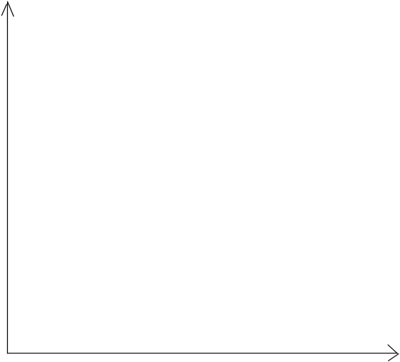
V_{acid} added/ cm³
pH
0
15.0

(i) Write a balanced chemical equation for the reaction between ethanoic acid and barium hydroxide.

(ii) Calculate the pH of the barium hydroxide solution.

(iii) Calculate the initial concentration (in mol dm^{–3}) of the ethanoic acid.

(iv) Suggest a suitable indicator for this titration.
..

(v) After 30 cm³ of ethanoic acid is added to the mixture, the solution is able to resist pH changes when a small amount of acid or alkali is added. Write two equations to explain why this is so.

[6]

(b) Aspirin, also known as acetylsalicylic acid, is a salicylate drug, often used as an analgesic to relieve minor aches and pains, as an antipyretic to reduce fever, and as an anti–inflammatory medication. The structure of aspirin is as shown below.

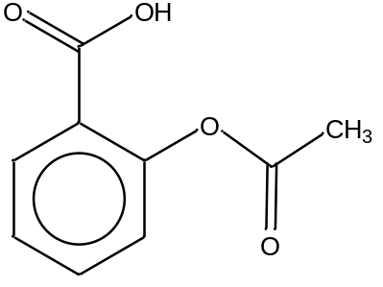

Aspirin

(i) Give the reagents and conditions to produce ethanoic acid from aspirin.
Reagents:
Conditions:

(ii) Explain why aspirin is insoluble in water.
..

(iii) However, aspirin is soluble in aqueous sodium hydroxide at room temperature. Explain, with the aid of an equation, why this is so.
..
[4]
[Total: 10]

3(a) Nitrogen trichloride is a yellow, oily, pungent–smelling liquid is most commonly encountered as a byproduct of chemical reactions between ammonia–derivatives and chlorine. It is also used as a bleaching agent for flour in the Agene process. An energy level diagram involving nitrogen trichloride is shown below.
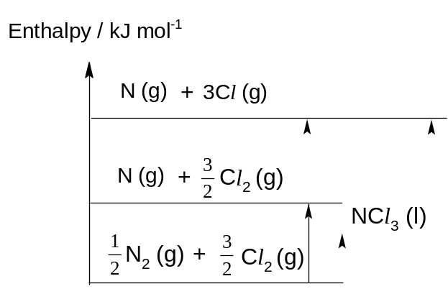
ΔH_{at}^{θ}(N₂)

(i) Define the term standard enthalpy change of formation.
..

(ii) Using ΔH_{f}^{θ}(NCl₃), bond energy (N–Cl) and bond energy (Cl–Cl), label the enthalpy changes of the processes involved on the energy level diagram above.

(iii) Hence, use the information given below and relevant data from the Data Booklet to calculate the bond energy of N–Cl bond.
ΔH_{f}^{θ}( NCl₃) = +232 kJ mol^{–1}

[6]

(b) A student used the apparatus below to determine the enthalpy change of combustion of propan–1–ol. It was found that 0.60 g of propan–1–ol was used to raise the temperature of 200 g of the water. The initial temperature of the water was 21.0°C.
The specific heat capacity of water is 4.18 J g^{–1} K^{–1}.

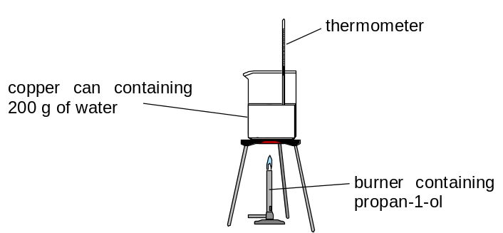

(i) Calculate the number of moles of propan–1–ol burnt.

(ii) Given that the enthalpy of combustion of propan–1–ol is –2021 kJ mol^{–1}, calculate the final temperature of water at the end of the experiment.

(iii) The actual temperature of the water measured at the end of experiment is 38.0C. Give an explanation for the difference.
..
[4]

[Total: 10]
4 Acrolein is formed when fats or vegetable oils are cooked at high temperatures. In fried foods, it may upset the stomach.

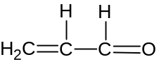

(a) (i) Name the functional group(s) found in acrolein.

(ii) Give the IUPAC name for acrolein.

[2]
(b) The C=O and C=C bonds have the same electronic structure and they undergo typically addition reactions.

(i) What do you understand by the term ‘addition’?
..

(ii) Suggest suitable reagent(s) and condition(s) to bring about an addition reaction of the C=O bond.
Reagent for C=O:
[2]

(c) Draw the structural formula(e) of the product(s) formed when acrolein reacts with each of the following reagents. Include the formula of other products formed (if any).

(i) | hydrogen in platinum catalyst
(ii) | acidified potassium dichromate(VI)
(iii) | Fehling’s solution

[3]
(d) Methacrolein is a clear colourless flammable liquid that has a similar structure to acrolein.
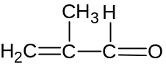

There are two isomers of methacrolein, S and T, both of which react differently when subjected to alkaline aqueous iodine and Tollens’ reagent.

Like methacolein, S forms a precipitate with Tollens’ reagent but not with alkaline aqueous iodine.

On the other hand, T forms a precipitate with alkaline aqueous iodine but not with Tollens’ reagent.

(i) What deduction can you make about the isomers when a precipitate is formed upon reacting with

- alkaline aqueous iodine, and

- Tollen’s reagent

(ii) Use your deductions to propose the structures of S and T.

 |  | S: | T:
[3]

[Total: 10]

Section B

Answer two questions from this section on separate answer paper.

1(a) Chlorine is a common element which can be found in many inorganic as well as organic compounds. The most common isotope of chlorine is 35–chlorine.

- Write the symbol (include mass number) of the other isotope of chlorine and calculate the relative abundance of this isotope.

  - Write an equation to represent the first ionisation energy for chlorine.

  - Using the Data Booklet, explain the difference in first ionisation energy between chlorine and bromine.
[7]

(b) Chlorine can form ionic compounds with Group I and II metals. The table below shows the lattice energies of two chlorine-based ionic compounds.

Ionic compound | Lattice energy/ kJ mol^{–1}
potassium chloride | –701
calcium chloride | –2237

- Define the term lattice energy.

- Explain the difference in the lattice energy between potassium chloride and calcium chloride.

- Calcium ion and chloride ion are separately subjected to the effect of an electric field as shown below. Copy this diagram, and draw and label clearly the path of the ions under the influence of the electric field.

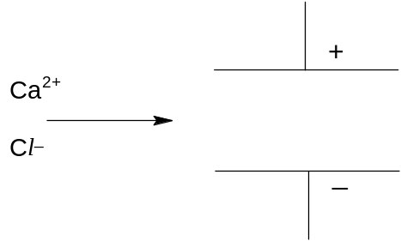

[6]

(c) The commercial insecticide DDT is an organochlorine first discovered by Swiss chemist Paul Hermann Müller. It is nearly insoluble in water but very soluble in organic solvents and fats.
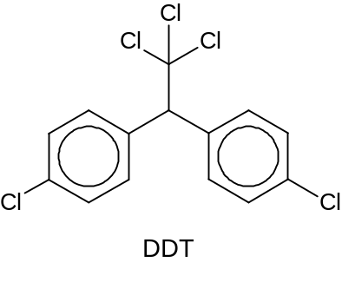
Consider the reaction scheme given below.

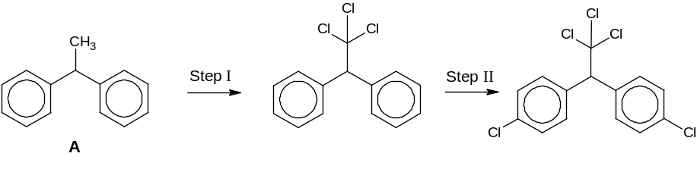

- Provide the reagents and conditions required for Step I and Step II.

- Predict and explain if Compound A or DDT will have a higher melting point.

- Why is the compound 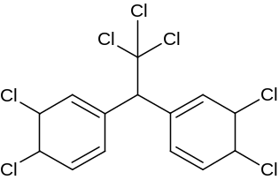 not formed in Step II?

- Draw the structural formula of the product formed when DDT reacts with excess aqueous sodium hydroxide assuming chlorobenzene will not react.
[7]
[Total: 20]

2. Methane is used to produce synthesis gas (syngas), a mixture that includes carbon monoxide and hydrogen, by reacting with steam on a nickel catalyst. Syngas is then used to produce liquid hydrocarbons and methanol.
CH₄ (g) + H₂O (g) CO (g) + 3H₂ (g)
A total of 5 mol gas mixture comprising of methane and steam is mixed in a 1:1 ratio in a
2 dm³ vessel. After some time, 1 mol of methane is found to be remaining at equilibrium.

(i) How many moles of methane have reacted? Calculate the number of moles of steam reacted as well as those of carbon monoxide and hydrogen gas produced.

(ii) Write an expression for the equilibrium constant, K_{c} and determine its value, including units.

(iii) It is known that this reaction is an endothermic process. What is meant by the term in italics?

(iv) Predict and explain the effect of separately increasing pressure and decreasing temperature on the above equilibrium as well as on the yield.

(v) In practice, a moderately high pressure is used in the production of syngas. Suggest a reason for this.

(vi) Sketch a graph showing how the rates of the forward and reverse reactions change with time, from the point of mixing to the point after equilibrium is established. Label your graphs clearly, showing the time at which equilibrium is established.
[13]
(b) To manufacture methanol, the carbon monoxide and hydrogen mixture is passed over a mixture of copper, zinc oxide and alumina catalysts. Besides being a common laboratory solvent, the largest use of methanol (CH₃OH) is to produce methanal (HCHO).

(i) Industrially, oxygen is used to react with methanol to produce methanal. Write an equation for this reaction.

(ii) Alternatively, what reagent(s) and condition(s) can be used in the laboratory to convert methanol to methanal?

(iii) Sketch the shape of the hybrid orbitals around the carbon in methanal molecule.
[3]

(c) A sample of methane reacts with excess bromine to form a mixture of brominated products.

(i) Identify the type of reaction that has occurred.
(ii) One of the products is found to have the composition by mass: C, 6.9%; H, 1.2% and Br, 91.9%. Draw the displayed formula of this product.
(iii) Write the structural formulae of two other brominated products.
[4]
[Total: 20]
3(a) The oxo reaction is an important industrial process in which an alkene combines directly with carbon monoxide and hydrogen under suitable conditions. The reaction with ethene is shown below.
catalyst
high T, p
CH₂=CH₂ + CO + H₂ CH₃CH₂CHO

(i) What is the simple relationship between the time taken for the reaction and the initial rate of the reaction?

(ii) A series of experiments are carried out to investigate the kinetics of the oxo reaction with ethene. The following results are obtained.
Experiment | [CH₂=CH₂]  / mol dm^{–3} | [CO] / mol dm^{–3} | [H₂] / mol dm^{–3} | Time / s
1 | 0.200 | 0.100 | 0.500 | 500
2 | 0.400 | 0.200 | 0.250 | 250
3 | 0.400 | 0.200 | 0.500 | 125

It is determined that the order of reaction with respect to carbon monoxide is 1.
(I) Calculate the initial rate for each of the three experiments, and use the results to determine the order of reaction with respect to CH₂=CH₂ and H₂.

(II) Hence write a rate equation for the reaction and calculate a value for the rate constant, giving its units.

(iii) Draw the structural formula of the product of the oxo reaction if the starting alkene is but–2–ene instead. [8]

(b) Propanal can be prepared from chloroethane under laboratory conditions, using propanoic acid as an intermediate. Propose a reaction scheme, in not more than 4 steps, for this conversion. Your answer should include the reagents and conditions, as well as the structures of the intermediate compounds formed. [3]

(c) Both ethanol and chloroethane can undergo a similar reaction to form ethene but using different reagents and conditions.
(i) Suggest the name of this reaction.

(ii) Give the reagents and conditions to form ethene from ethanol and chloroethane respectively. [3]

(d) While Sean is doing his experiment in the laboratory, the labels of 3 test–tubes each containing 1–phenylethanol, 1–bromoethylbenzene and 1–chloroethylbenzene fell off. The structures of the 3 compounds are shown below:
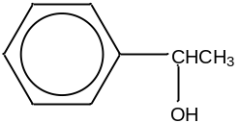 | 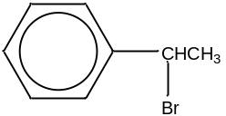 | 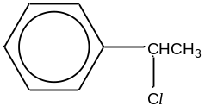
1–phenylethanol | 1–bromoethylbenzene | 1–chloroethylbenzene

(i) Suggest how Sean can carry out 2 different tests to distinguish the 3 compounds from one another. For each test, state the reagents and conditions, and give the observations you would make with each compound.

(ii) Both 1–bromoethylbenzene and 1–chloroethylbenzene can react with ethanolic ammonia to form amines. Predict and explain which of the two compounds will have a faster reaction with ethanolic ammonia. [6]

[Total: 20]

